**Project “FirstRPG”   
Art Direction Concept Document**

Philosophy of this particular Art Direction:

* As it is my first game, this will be very **loosely directed**.
* The general idea is **Zelda** + **Banjo** with a **comic** **adult** **twist**.
* The setting is 3018 and reality does not make sense anymore. Bright colors contrasted with dirty and smokey environments.
* Items, abilities and spells are insane but simple, functional and beautiful.

Summary of Art Direction

This camera, lighting, perspective, overall feel....

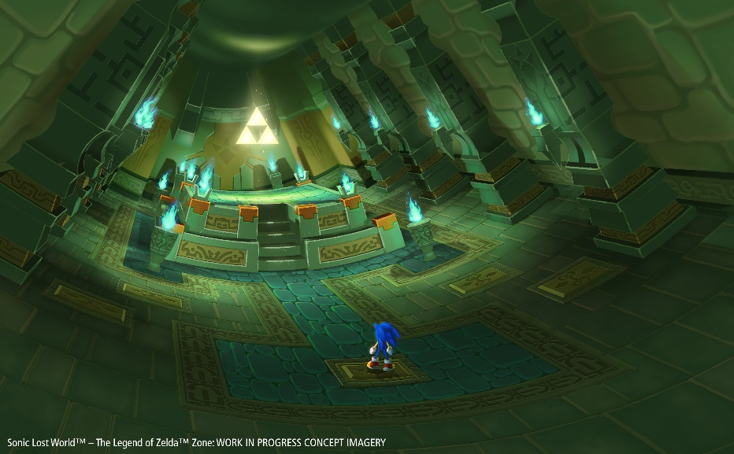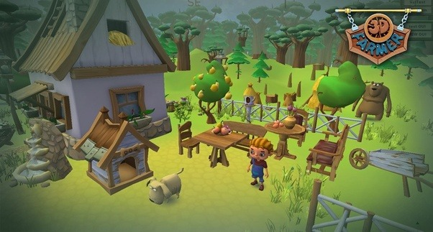

With these images of characters, enemies, people, monsters…

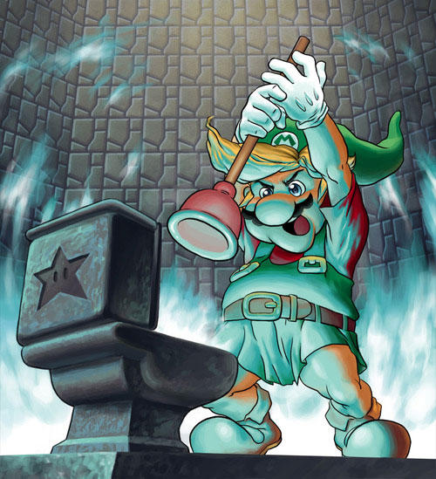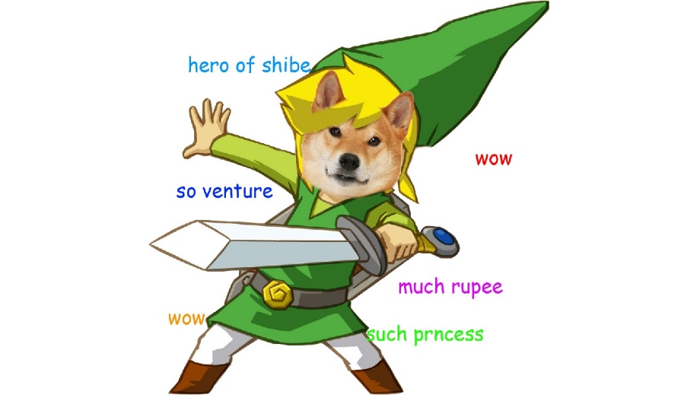

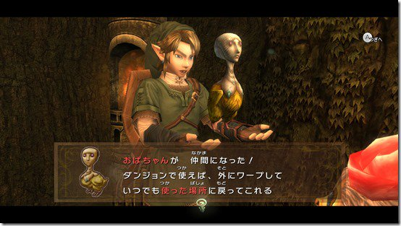 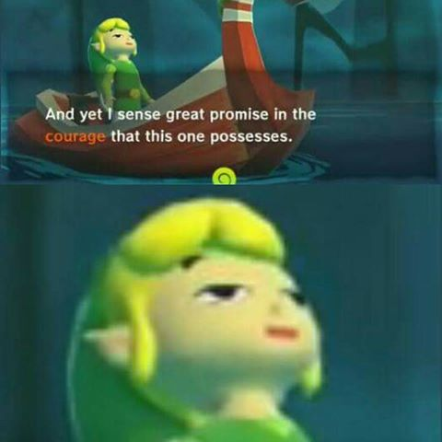

In these settings / locations…

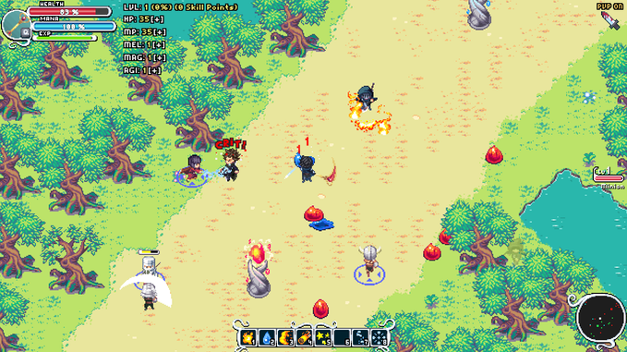 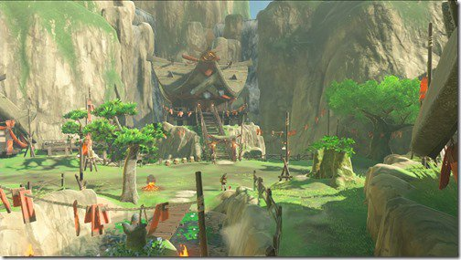

With this sort of polish / effects…

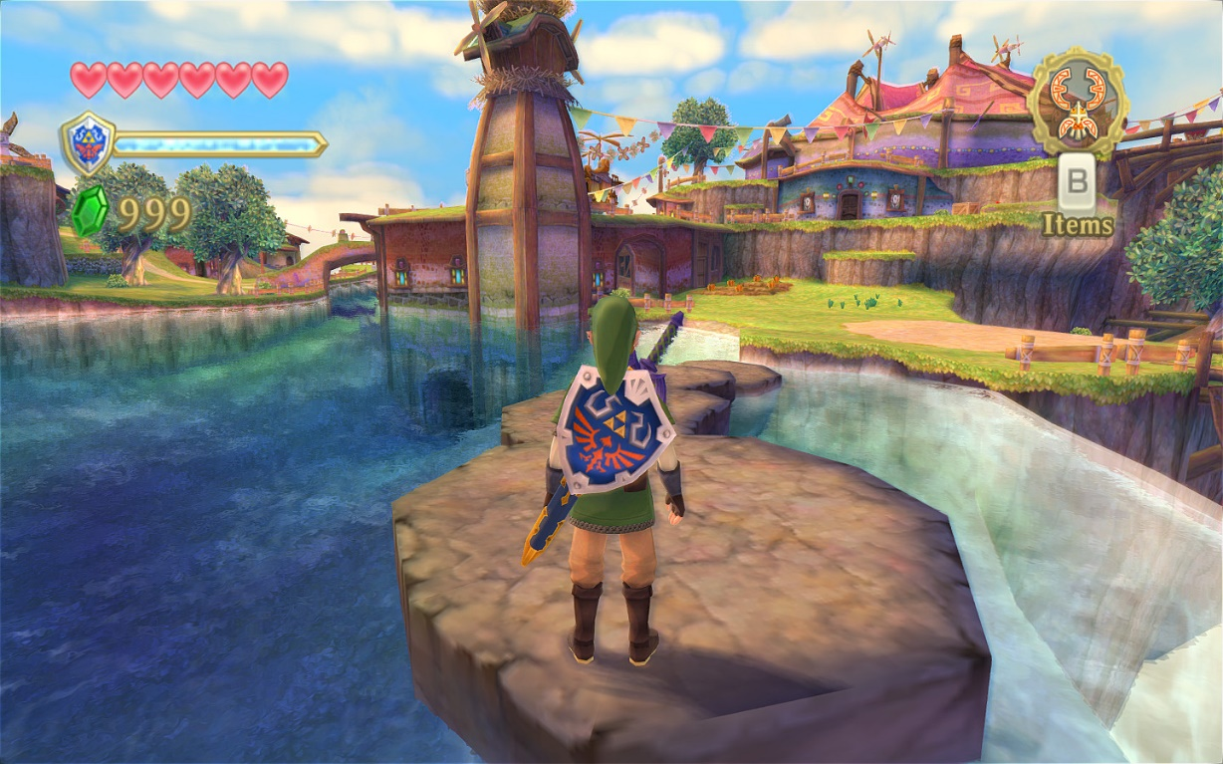

With this type of colour palette…

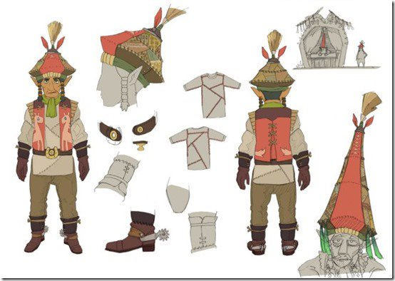 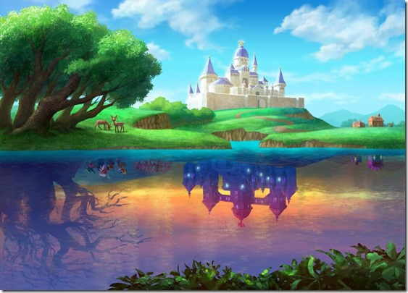

More Detailed Explanation



If useful, go through some of the images you that found and particularly liked, highlighting what aspects you like. Eg. the shape of a building, the clothes of a character, the lighting of a room and so on.

You might have 3 images in this section, you might have 30 - put in as many as is useful to yourself or to an artist who might be working on the project with you.